# Sprint 1 Plan - Planetarium

Scrumbags

## Sprint Completion 10/24/2023, Revision 1, 10/11/2023

# Goal

Create the basic and foundational functionality and UI for the application. Establish infrastructure and get familiar with Flutter and Firebase.

# Task Listing

Check [here](https://plannertarium.atlassian.net/jira/software/projects/PLANNER/boards/1) for the most up to date view.

[1] Create events

* As a user, I would like to add an event to my calendar so that… [this story can be split into 2 stories] This is your epic
  + Story 1 As a user I would like a simple form to type in my event info so that …
    - Create a UI for the form ? []
    - How do I take in user input in a way such that I can send it to a databse
    - Building: a UI form , button (that does nothing except aggregate the text in the form)
  + Story 2 As a user I would like my event info to not be lost even if I log out and log back in. [database]
    - How do i store information in a database?
    - Given some aggregated text (that you make up, but resembles the text from the UI form), send this data to the DB.
    - Requirement: the API call needs to be stateless
  + As a user, I want the aggreated data from story 1 to be pushed into the database from [story 2]

[2] Create tasks

[3] edit tasks/events

1. As a user, I want to manage my tasks and events separately so I do not get confused between what my tasks are for the day and what are my scheduled events

Create a database with proper rules - 3h

Create basic unit tests for the database - 2h

Create data format to use with the database - 1h

Differentiate events and tasks on the UI - 3h

Add task support to database - 2h

Add event support to database - 2h

Total 13h

1. As a user, I want to have control over the time window view (weekly/daily etc.) so I can I can see however much detail I desire

Create daily/weekly/monthly UI view - 3h

Create options for events - 2h

Total 5h

1. As a user, I want a view of the current event so I can quickly see and take note of what is happening

Add filter for tasks and events - 4h

Add current event view - 2h

Total 6h

# Team Roles

Steven Xue - Backend developer

Liam Xu - Frontend developer

Andrew Hu - frontend developer, backend developer

Andrew Yegiayan - backend developer

Cheng Wai Chong - frontend developer

# Initial Task Assignment

Cheng Wai Chong - US2, Create daily/weekly/monthly UI view

Liam Xu - US2, create daily/weekly/monthly UI view

Andrew Yegiayan - US1, Create a local database

Steven Xue - US1, Create a local database

Andrew Hu - US2, Create daily/weekly/monthly UI view

# Initial Burnup Chart

[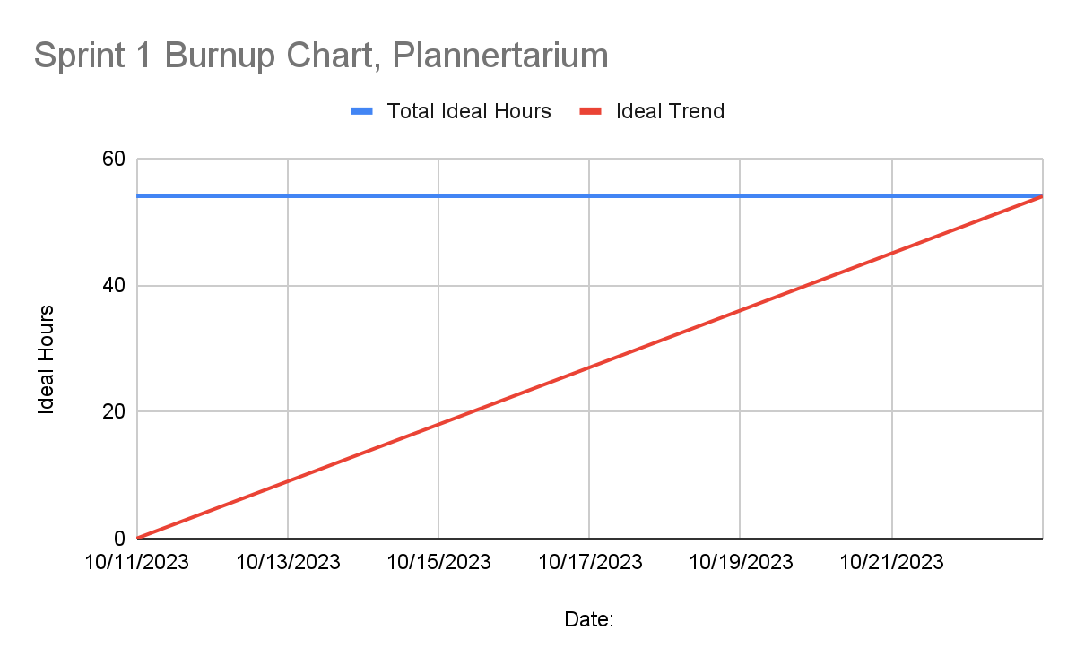](https://docs.google.com/spreadsheets/d/1SIR27Als7d3w4lPVdqzzbS3_kFWKfvY5UqsysHPZ46M/edit#gid=0)

# Initial Scrum Board

[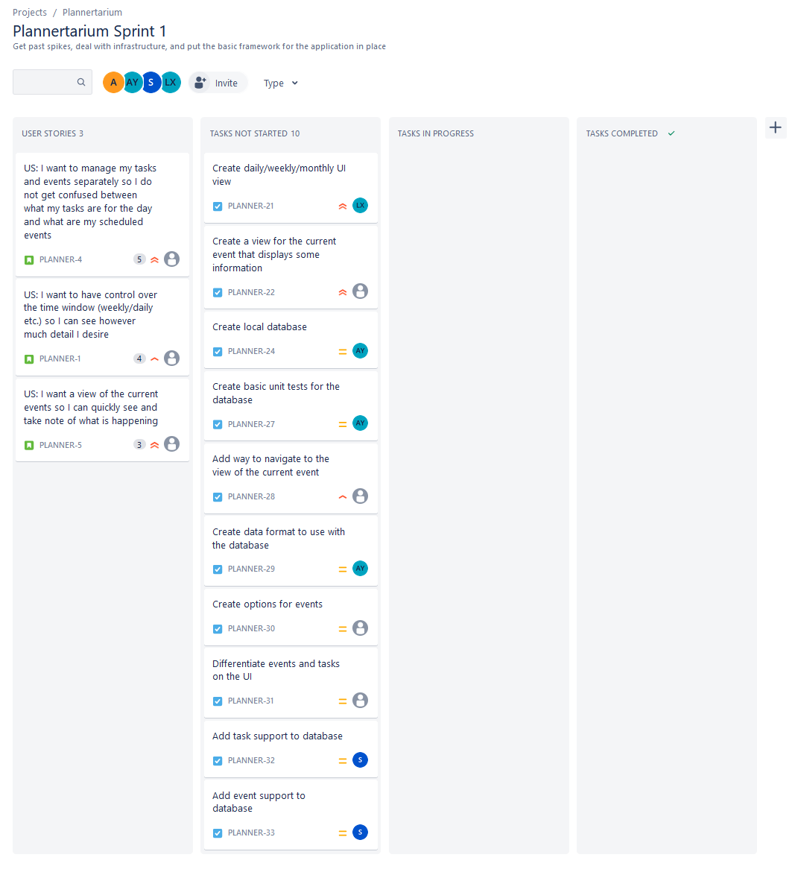](https://plannertarium.atlassian.net/jira/software/projects/PLANNER/boards/1)

# Scrum Times

Monday 12:00pm

Tuesday 9:15 am

Thursday 9:15 am